REFEREES WANTED
COULD THIS BE YOU?
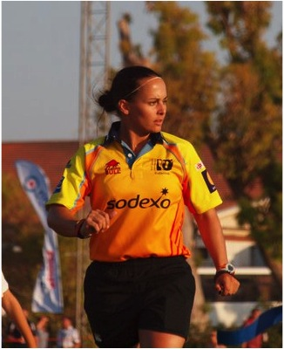
The community Game needs Referees!
Could you help?
Why not give Refereeing a try?
Next best thing to playing
You get the best seat in the house
Could a Referee Course at your club help?
The LSRFUR Take Up The Whistle course could be for you?
Course could be run at your club – minimum number 11 candidates
Minimum age :- 14
Cost £25 per person
You will get a Whistle, Red & Yellow card set, LSRFUR lanyard, Notepad.
For further details please contact :-
Bob Ockenden
Email :- bob.ockenden@londonrugby.com

