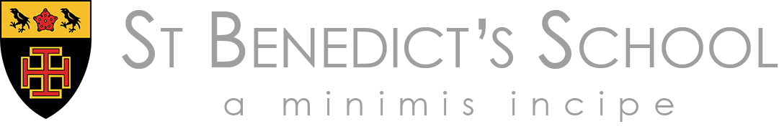

Co-educational Independent Catholic Day School
(HMC & IAPS) 3 – 18
London W5 2ES

Required for September 2026

Sports Coach with specialism in Rugby, Football and Cricket
(8-14 hours per week including Saturdays, Term Time)

We are seeking to appoint dynamic, self-motivated, highly organised, and experienced coaches to work within our successful Sports Programmes and busy and thriving Games Department.

It is essential that applicants are able to deliver Rugby, Football and Cricket and hold a minimum Level 1 and working towards Level 2 or equivalent coaching qualification.

Interviews will take place as and when we receive applications.

We encourage early applications, as we may close the vacancy earlier than advertised if we receive a high volume of suitable applications or make an appointment from early applicants.

To apply
If you would like to be considered for this role, please complete our online application form, available on the St Benedict’s website. We are only able to consider applications submitted using the school’s application form.

If you have any questions or would like further information, please contact our HR department on 020 8862 2185 or email recruitment@stbenedicts.org.uk.

Safeguarding and Safer Recruitment
St Benedict’s is committed to safeguarding and promoting the welfare of children and young people. The successful applicant will be required to undergo all appropriate safeguarding checks relevant to the post, including enhanced DBS clearance, online searches, satisfactory references with current and previous employers and verification of identity and right to work in the UK.

Equality, Diversity and Inclusion
We value the diversity of our community and are committed to promoting equality of opportunity for all. We welcome applications from candidates of all backgrounds and do not discriminate on the grounds of any protected characteristic. Our aim is to create an inclusive environment where every member of our community is respected and able to thrive.

Accessibility
We are committed to making our recruitment process accessible and welcoming. If you require the application form in a different format, or need any adjustments or support to complete your application, please contact us on 020 8862 2185 or at recruitment@stbenedicts.org.uk. We will be pleased to support you to ensure your needs are met.

